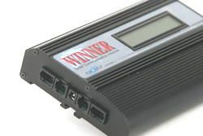


WINNER-1

PC programmable, highly advanced software features.

Main features :

- Two simultaneous calls to any two cellular operators
- Dual channel utilizes 8 SIMs (enabling two simultaneous outgoing calls) using 1-4 SIMs per port
- Intelligent LCR (Least Cost Routing) with up to 4 cellular networks
- Reverse polarity: Battery reversal, Double polarity reverse or by break of line
- Windows based powerful management system
- LCD shows network, signal strength, call status, and programming
- Each SIM has up to 32 prefixes, user may set a specific tariff for each of the 32 prefixes
- The unit uses its own comfort tone for accessing other networks, in this case it may add about 5-6 sec to the outgoing call
- LCR by prefix or timetable, day of week, hours to call and by number of calls
- All programming and monitoring may be done via the PC or DTMF and viewed on the LCD
- CLID, PIN, audio set capability via s/w, DTMF or PC
- Pulse meter 12Khz or 16Khz capability
- Analogue FXS (trunk) or FXO (extension is optional) interface
- Network locking or SIM locking is optional
- Data, fax, SMS and GPRS capability is optional
- Can connect over VOIP Gateway
- GSM Dual band 900MHz/1,800MHz or 850MHz/1,900MHz

