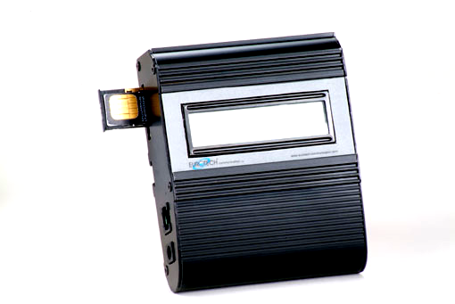
CALLER-1 Characteristics

General technical information
Electrical
- Power supply: 12 VDC +/- 5% 1,2 A
- 720 mA average in GSM 900 at Tx power max 2W
- 920 mA average in GSM/GRPS 900 at Tx power max 2W
- 100 mA in idle mode
Physical
- Absolute maximum dimension: 165 x 127 x 30 mm
- Weight: 600 g
- Casing: Complete shielding-stainless steel
- Mounting: 4 screw holes
- Operating temperature range: -5°C to + 55°C
Optimal storage temperature: -35°C to +85°C

Analog Telephone/Analog PBX interface

- Tip/Ring Voltage –48V
- Line current 25ma
- Ringing Voltage 140 Vpp

Load 3REN
Crest Factor 1.25
Frequency 20 Hz
Cadency 2s/4s
- Answer supervision - Reverse polarity
- DTMF compliancy
- Dial Tone 400 Hz
Busy Tone 400 Hz, cadency 500ms/500ms
GSM circuit Data Features
Data circuit asynchronous, transparent and non transparent up to 14,400 b/s
Automatic fax group 3 (Class 1 & 2)
Alternate speech and fax
MNP2, V.42bis

Telephone Line Characteristics

DC Characteristics
Ringing Voltage: -70 V DC typical
On hook voltage: -58 V DC typical
Off hook Voltage: -24 V DC typical
Off hook Loop current: 27mA @ 600 Ohm programming resistive
Input Impedance: 480 Ohms to 720 Ohms, 600 ohm typical

DTMF Dialling:
Detection level: -25dBm to +3dBm
On time: 50msec.
Off time: 12 characters

Ringing Signal:
Feeding type: Balanced signal
Distortion: Less than 5%
Ring drive capability 3 type A
Minimum ring Voltage: 40 Vrms – crest factor 1.2
Frequency: (20 Hz )

Normal dialling tone:

( can be changed per customer request )
Frequency: 400Hz
Level: 2dB
Cadence: continuous

Congestion / Busy Tone: ( can be changed per customer request )
Frequency: 400Hz
Level: 2dB
Cadence: 500ms 20% signal
500ms 20% pause

Environmental characteristics
Compliance:
The CALLER-1 complies to the following requirements:

Temperature -10 to 70

Humidity 5% to 95%

Packing
Per ElectrOnde standard

Transportation
Transport conditions are according to ElectrOnde Standards.

Storage Condition
Storage conditions are according to class 1.1, ETS 300 019 –1-1 (-20°C +80°C)
-25°C to +65°C

Mounting

Wall Mounting
In case you wish to mount on wall see instructions above in General Information.
configuration the CALLER-1 attached to the wall with one screw.

Desk – Top Mount
In desk top mounting configuration on four rubber standoffs, it should be mounted
at least .5 meter from the telephone set.

Packing
Each CALLER-1 package contains:
One CALLER-1 unit, metal box.
One Omni antenna or an external antenna (optional)
This booklet which includes a user manual.

Labels
Each CALLER-1 labelled as the following :
Product ID: located at the box side( in future units).
The label contains product model number, Serial number, Date and code identified
as WWYY
(1’st two digits identify the chronological week in the year, 2nd tow digits identify the
year), Hardware and Software
version. For Example: Logo, Model No, Serial No, Rev.
HardwareX/SoftwareY:0X/0Y , Date: Month/Year

Manufacturing
At ElectrOnde we bear in mind at all times manufacturing at high Quality and cost effective are the most significant considerations in the design for Manufacturing of the CALLER-1.

Shipment
All goods will be sold FOB, customer will pay for delivery from factory.
Customer will advise on the way the products will be shipped.
Customer will take care of shipment including all necessary payments for
insurance, delivery, custom, etc. as FOB requires.

Reliability
The CALLER-1 Field Quality goal is and will be determined by reliability prediction actual ALT results.
Our target is: 0.5-1.0% per month, this goal is susceptible to changes.

